Week 08: Graph Algorithms 2

Weighted Graphs

Weighted Graphs | 2/40
Graphs so far have considered
- edge = an association between two vertices/nodes
- may be a precedence in the association (directed)
Some applications require us to consider
- a cost or weight of an association
- modelled by assigning values to edges (e.g. positive reals)
Weights can be used in both directed and undirected graphs.

... Weighted Graphs | 3/40
Example: major airline flight routes in Australia
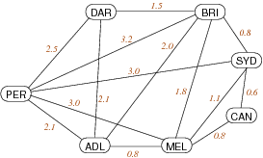
Representation: edge = direct flight; weight = approx flying time (hours)

... Weighted Graphs | 4/40
Weights lead to minimisation-type questions, e.g.
1. Cheapest way to connect all vertices?
- a.k.a. minimum spanning tree problem
- assumes: edges are weighted and undirected
2. Cheapest way to get from A to B?
- a.k.a shortest path problem
- assumes: edge weights positive, directed or undirected

Exercise #1: Implementing a Route Finder | 5/40
If we represent a street map as a graph
- what are the vertices?
- what are the edges?
- are edges directional?
- what are the weights?
- are the weights fixed?
What kind of algorithm would ...
- help us find the "quickest" way to get from A to B?

Weighted Graph Representation | 6/40
Weights can easily be added to:
- adjacency matrix representation (0/1 → int or float)
- adjacency lists representation (add int/float to list node)
An alternative representation useful in this context:
- edge list representation (list of (s,t,w) triples)
All representations work whether edges are directed or not.

... Weighted Graph Representation | 7/40
Adjacency matrix representation with weights:
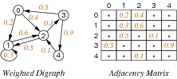
Note: need distinguished value to indicate "no edge".

... Weighted Graph Representation | 8/40
Adjacency lists representation with weights:
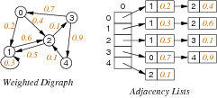
Note: if undirected, each edge appears twice with same weight

... Weighted Graph Representation | 9/40
Edge array / edge list representation with weights:
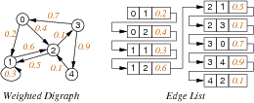
Note: not very efficient for use in processing algorithms, but does
give a possible representation for min spanning trees or shortest paths

... Weighted Graph Representation | 10/40
Sample adjacency matrix implementation in C requires minimal changes to previous Graph ADT:
WGraph.h

typedef struct Edge {
Vertex v;
Vertex w;
int weight;
} Edge;

int adjacent(Graph, Vertex, Vertex);

... Weighted Graph Representation | 11/40
WGraph.c
typedef struct GraphRep {
int **edges;

int nV;
int nE;
} GraphRep;

void insertEdge(Graph g, Edge e) {
assert(g != NULL && validV(g,e.v) && validV(g,e.w));
if (g->edges[e.v][e.w] == 0) {
g->edges[e.v][e.w] = e.weight;
g->edges[e.w][e.v] = e.weight;
g->nE++;
}
}

int adjacent(Graph g, Vertex v, Vertex w) {
assert(g != NULL && validV(g,v) && validV(g,w));
return g->edges[v][w];
}

Minimum Spanning Trees

Minimum Spanning Trees | 13/40
Reminder: Spanning tree ST of graph G(V,E)
- spanning = all vertices, tree = no cycles
- ST is a subgraph of G (G'=(V,E') where E' ⊆ E)
- ST is connected and acyclic
Minimum spanning tree MST of graph G
- MST is a spanning tree of G
- sum of edge weights is no larger than any other ST
Applications: Computer networks, Electrical grids, Transportation networks …
Problem: how to (efficiently) find MST for graph G?
NB: MST may not be unique (e.g. all edges have same weight ⇒ every ST is MST)

... Minimum Spanning Trees | 14/40
Brute force solution:
findMST(G):
| Input graph G
| Output a minimum spanning tree of G
|
| bestCost=∞
| for all spanning trees t of G do
| | if cost(t)<bestCost then
| | bestTree=t
| | bestCost=cost(t)
| | end if
| end for
| return bestTree
Example of generate-and-test algorithm.
Not useful because #spanning trees is potentially large (e.g. n^{n-2} for a complete graph with n vertices)

... Minimum Spanning Trees | 15/40
Simplifying assumption:
- edges in G are not directed (MST for digraphs is harder)

Kruskal's Algorithm | 16/40
One approach to computing MST for graph G with V nodes:
- start with empty MST
- consider edges in increasing weight order
  - add edge if it does not form a cycle in MST
- repeat until V-1 edges are added
Critical operations:
- iterating over edges in weight order
- checking for cycles in a graph

... Kruskal's Algorithm | 17/40
Execution trace of Kruskal's algorithm:
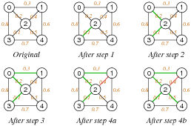

Exercise #2: Kruskal's Algorithm | 18/40
Show how Kruskal's algorithm produces an MST on:
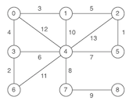

After 3rd iteration:
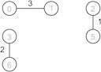
After 6th iteration:
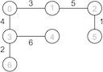
After 7th iteration:
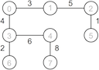
After 8th iteration (V-1=8 edges added):
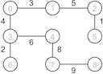

... Kruskal's Algorithm | 20/40
Pseudocode:
KruskalMST(G):
| Input graph G with n nodes
| Output a minimum spanning tree of G
|
| MST=empty graph
| sort edges(G) by weight
| for each e∈sortedEdgeList do
| | MST = MST ∪ {e}
| | if MST has a cyle then
| | MST = MST \ {e}
| | end if
| | if MST has n-1 edges then
| | return MST
| | end if
| end for

... Kruskal's Algorithm | 21/40
Rough time complexity analysis …
- sorting edge list is O(E·log E)
- at least V iterations over sorted edges
- on each iteration …
  - getting next lowest cost edge is O(1)
  - checking whether adding it forms a cycle: cost = ??
Possibilities for cycle checking:
- use DFS … too expensive?
- could use Union-Find data structure (see Sedgewick Ch.1)

Prim's Algorithm | 22/40
Another approach to computing MST for graph G=(V,E):
- start from any vertex s and empty MST
- choose edge not already in MST to add to MST
  - must be incident on a vertex already connected to s in MST
  - must have minimal weight of all such edges
- repeat until MST covers all vertices
Critical operations:
- checking for vertex being connected in a graph
- finding min weight edge in a set of edges

... Prim's Algorithm | 23/40
Execution trace of Prim's algorithm (starting at s=0):
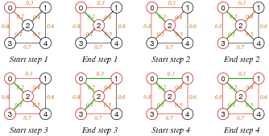

Exercise #3: Prim's Algorithm | 24/40
Show how Prim's algorithm produces an MST on:

Start from vertex 0

After 1st iteration:
After 2nd iteration:
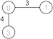
After 3rd iteration:
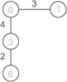
After 4th iteration:
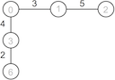
After 8th iteration (all vertices covered):


... Prim's Algorithm | 26/40
Pseudocode:
PrimMST(G):
| Input graph G with n nodes
| Output a minimum spanning tree of G
|
| MST=empty graph
| usedV={0}
| unusedE=edges(g)
| while |usedV|<n do
| | find e=(s,t,w)∈unusedE such that {
| | s∈usedV ∧ t∉usedV ∧ w is min weight of all such edges
| | }
| | MST = MST ∪ {e}
| | usedV = usedV ∪ {t}
| | unusedE = unusedE \ {e}
| end while
| return MST
Critical operation: finding best edge

... Prim's Algorithm | 27/40
Rough time complexity analysis …
- V iterations of outer loop
- in each iteration …
  - find min edge with set of edges is O(E) ⇒ O(V·E) overall
  - find min edge with priority queue is O(log E) ⇒ O(V·log E) overall
Note:
- Using a priority queue gives a variation of DFS (stack) and BFS (queue) graph traversal

Sidetrack: Priority Queues | 28/40
Some applications of queues require
- items processed in order of "key"
- rather than in order of entry (FIFO — first in, first out)
Priority Queues (PQueues) provide this via:
- join: insert item into PQueue (replacing enqueue)
- leave: remove item with largest key (replacing dequeue)

... Sidetrack: Priority Queues | 29/40
Comparison of different Priority Queue representations:
 | sorted  array | unsorted  array | sorted  list | unsorted  list
space usage | MaxN | MaxN | O(N) | O(N)
join | O(N) | O(1) | O(N) | O(1)
leave | O(N) | O(N) | O(1) | O(N)
is empty? | O(1) | O(1) | O(1) | O(1)
for a PQueue containing N items

Other MST Algorithms | 30/40
Boruvka's algorithm ... complexity O(E·log V)
- the oldest MST algorithm
- start with V separate components
- join components using min cost links
- continue until only a single component
Karger, Klein, and Tarjan ... complexity O(E)
- based on Boruvka, but non-deterministic
- randomly selects subset of edges to consider
- for the keen, here's the paper describing the algorithm

Shortest Path

Shortest Path | 32/40
Path = sequence of edges in graph G p = (v₀,v₁), (v₁,v₂), …, (v_{m-1},v_{m})
cost(path) = sum of edge weights along path
Shortest path between vertices s and t
- a simple path p(s,t) where s = first(p), t = last(p)
- no other simple path q(s,t) has cost(q) < cost(p)
Assumptions: weighted digraph, no negative weights.
Finding shortest path between two given nodes known as source-target SPP problem
Variations: single-source, all-pairs
Applications: robot navigation, routing in data networks, …

Single-source Shortest Path (SSSP) | 33/40
Given: weighted digraph G, source vertex s
Result: shortest paths from s to all other vertices
- dist[] V-indexed array of cost of shortest path from s
- pred[] V-indexed array of predecessor in shortest path from s
Example:
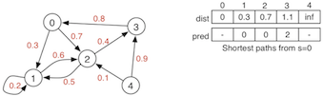

Edge Relaxation | 34/40
Assume: dist[] and pred[] as above (but containing data for shortest paths discovered so far)
dist[v] is length of shortest known path from s to v
dist[w] is length of shortest known path from s to w
Relaxation updates data for w if we find a shorter path from s to w:
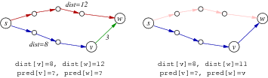
Relaxation along edge e=(v,w,weight):
- if dist[v]+weight < dist[w] then
update dist[w]:=dist[v]+weight and pred[w]:=v

Dijkstra's Algorithm | 35/40
One approach to solving single-source shortest path …
Data: G, s, dist[], pred[] and
- vSet: set of vertices whose shortest path from s is known
Algorithm:
dist[]
pred[]

dijkstraSSSP(G,source):
| Input graph G, source node
|
| initialise dist[] to all ∞, except dist[source]=0
| initialise pred[] to all -1
| vSet=all vertices of G
| while vSet≠∅ do
| | find s∈vSet with minimum dist[s]
| | for each (s,t,w)∈edges(G) do
| | relax along (s,t,w)
| | end for
| | vSet=vSet\{s}
| end while

Exercise #4: Dijkstra's Algorithm | 36/40
Show how Dijkstra's algorithm runs on (source node = 0):
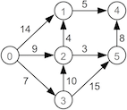

 | [0] | [1] | [2] | [3] | [4] | [5]
dist | 0 | ∞ | ∞ | ∞ | ∞ | ∞
pred | – | – | – | – | – | –

dist | 0 | 14 | 9 | 7 | ∞ | ∞
pred | – | 0 | 0 | 0 | – | –

dist | 0 | 14 | 9 | 7 | ∞ | 22
pred | – | 0 | 0 | 0 | – | 3

dist | 0 | 13 | 9 | 7 | ∞ | 12
pred | – | 2 | 0 | 0 | – | 2

dist | 0 | 13 | 9 | 7 | 20 | 12
pred | – | 2 | 0 | 0 | 5 | 2

dist | 0 | 13 | 9 | 7 | 18 | 12
pred | – | 2 | 0 | 0 | 1 | 2

... Dijkstra's Algorithm | 38/40
Why Dijkstra's algorithm is correct:
Hypothesis.
(a) For visited s … dist[s] is shortest distance from source
(b) For unvisited t … dist[t] is shortest distance from source via visited nodes
Proof.
Base case: no visited nodes, dist[source]=0, dist[s]=∞ for all other nodes
Induction step:
- If s is unvisited node with minimum dist[s], then dist[s] is shortest distance from source to s:
  - if ∃ shorter path via only visited nodes, then dist[s] would have been updated when processing the predecessor of s on this path
  - if ∃ shorter path via an unvisited node u, then dist[u]<dist[s], which is impossible if s has min distance of all unvisited nodes
- This implies that (a) holds for s after processing s
- (b) still holds for all unvisited nodes t after processing s:
  - if ∃ shorter path via s we would have just updated dist[t]
  - if ∃ shorter path without s we would have found it previously

... Dijkstra's Algorithm | 39/40
Time complexity analysis …
Each edge needs to be considered once ⇒ O(E).
Outer loop has O(V) iterations.
Implementing "find s∈vSet with minimum dist[s]"
- try all s∈vSet ⇒ cost = O(V) ⇒ overall cost = O(E + V²) = O(V²)
- using a PQueue to implement extracting minimum
  - can improve overall cost to O(E + V·log V) (for best-known implementation)

Summary | 40/40
- Weighted graph representations
- Minimum Spanning Tree (MST)
  - Kruskal, Prim
- Single source shortest path problem
  - Dijkstra

- Suggested reading:
  - Sedgewick, Ch.19.3,20-20.4,21-21.3

Produced: 14 Sep 2017

